Lifting

Position the lifting strops according to the diagram below, avoiding through hull transducers (speed log, depth & forward looking sonar) fitted just forward of the keel. These can be seen from the bilge area inside the boat just forward of the mast. When the lifting strops have been positioned, spring ropes should be attached fore and aft to the respective mooring cleats to prevent the strops from sliding. Most yards will provide plastic sheeting to cover their strops and protect the hull. When re-launching, always ensure that antifouling paint is dry before lifting. Always ensure the greatest caution when near and around the yacht during lifting manoeuvres and respect the regulations of the local facility.

NOTE: All weights quoted in this manual are approximate and are based on a half loaded vessel. Always be sure that the crane or travel lift being used has a safe over capacity for the weight of the vessel.

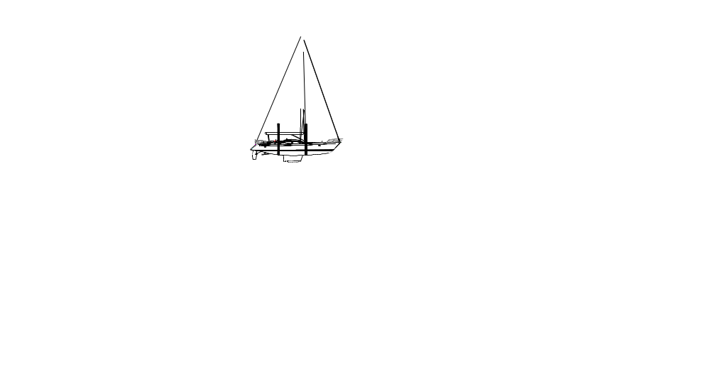
Lifting slings (avoiding speed log, depth & FLS transducers)
Lifting slings

Ensure that the slings are clear of the through hull transducers forward of the mast.

Shoring Up
We recommend the use of a suitable cradle with at least six legs. The weight of the vessel should be born on the keel, not on the individual legs. Additional supports should be added around the stern and bow areas of the hull. Ensure the yacht is positioned suitably to allow water to drain from the deck and cockpit areas and that deck drain valves are left open while the boat is stored ashore.

In final position, the yacht will appear LOWER AT THE BOW
in order to ensure all cockpit drains can do their job.

